Ideas for initial variables for MATHtication project

A. Does the shape of the occlusal surface affect the amount of antero-posterior translation required needed to maintain contact throughout the chewing cycle?

For one specimen, we could rotate the mandible through a range of positions.

1. using a transverse axis of rotation through both mandibular condyles
2. using a vertical axis of rotation through one condyle (vertical defined by previous PCA

At each position we calculate the amount of AP translation required to maximize contact area between upper and lower dentitions. We can produce a plot for each position of contact area against translation. We can then plot the “optimal” translation for each rotation position in a 2D plot that could then be compared for different morphologies/ degrees of wear.

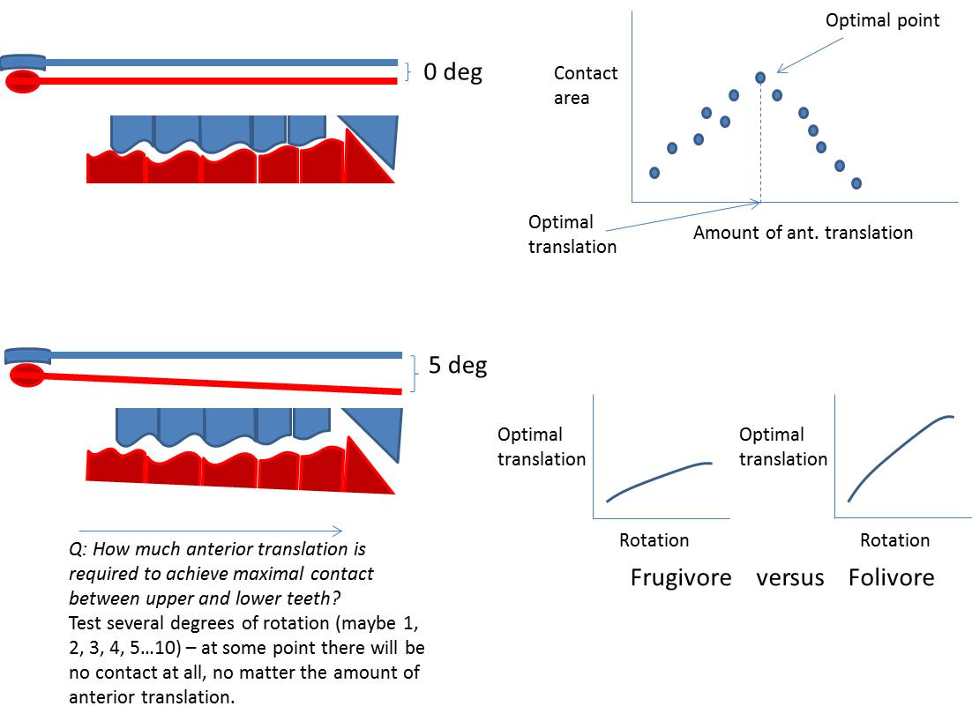

B. Does the shape of the occlusal surface affect the distribution of distances between upper and lower teeth as the jaw rotates?

Beginning as before with a range of rotation positions for the jaw – either around an axis running between condyles or around a vertical axis through one condyle.

For each position – calculate distances between upper and lower - (random sampling of upper points?)

The distribution of distances can be used to calculate various parameters that can then be plotted against rotation angle – e.g., standard deviation, average, maximum…

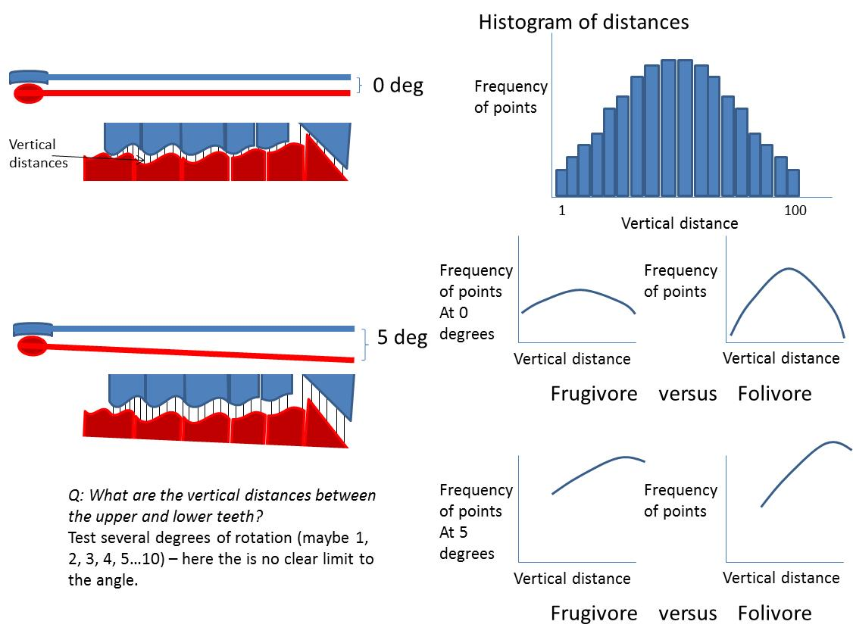

In either A or B above, the regions of interest could be narrowed from the whole surface down to particular characteristics, for example the most highly curved regions of the occlusal surface.